VPC | vpc-0f43aa31f169322bb
Internet gateway | igw-02711de4a58d2770c
Public subnet | subnet-05887a9607c9dec45
Private subnet | subnet-0c60b4d85130ccf7a
Public route table | rtb-0e3c8fa180d55a68d

VPC

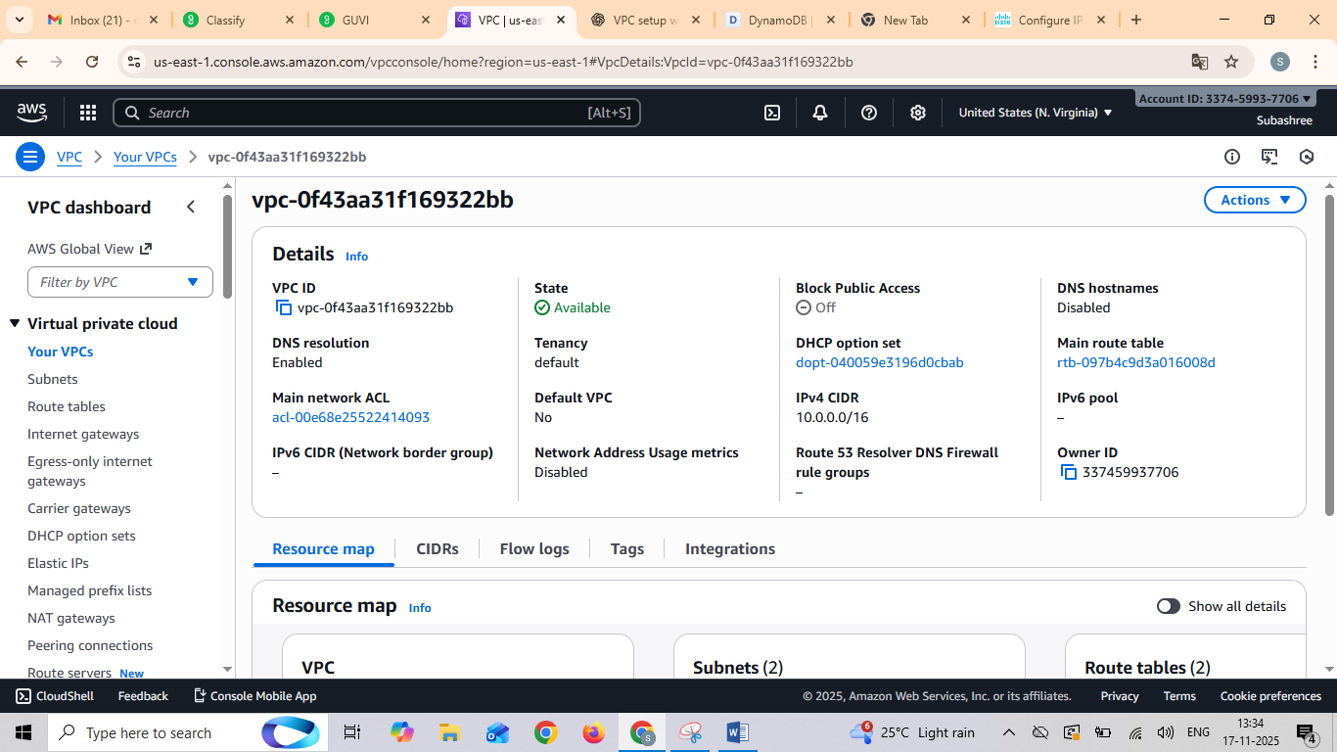

Twosubnets

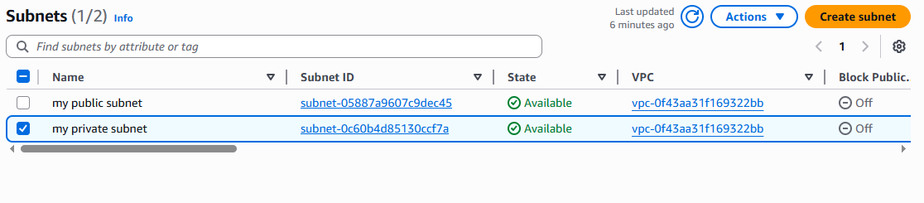

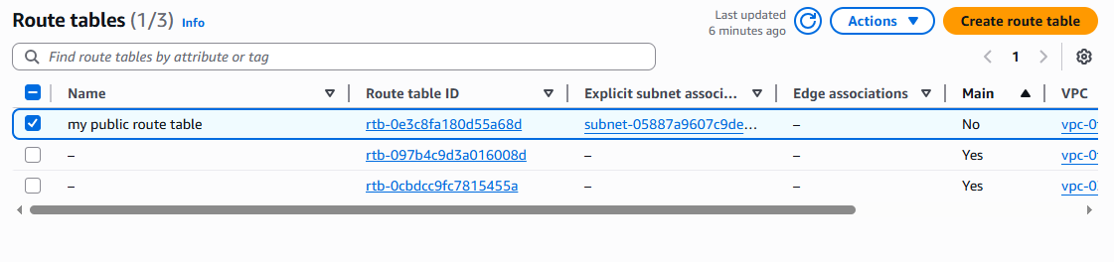
Internet gateway

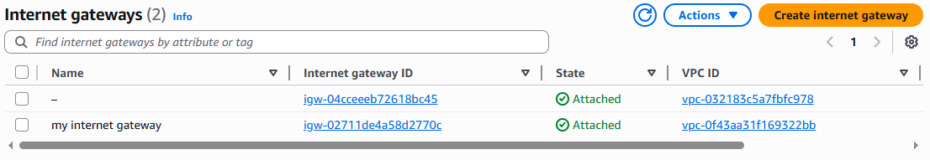

EC2 Instance

